**import** numpy **as** np *# linear algebra*

**import** pandas **as** pd *# data processing, CSV file I/O (e.g. pd.read_csv)*

**import** matplotlib.pyplot **as** plt

**import** seaborn **as** sns

**import** random

*# Input data files are available in the "../input/" directory.*

*# For example, running this (by clicking run or pressing Shift+Enter) will list all files under the input directory*

**import** os

**for** dirname, _, filenames **in** os**.**walk('/kaggle/input'):

**for** filename **in** filenames:

print(os**.**path**.**join(dirname, filename))

*# Any results you write to the current directory are saved as output.*

**%**matplotlib inline

In [10]:

data **=** pd**.**read_csv('/content/rainfall_India_2017.csv')**.**rename(columns**=**str**.**lower)

plt**.**style**.**use('fivethirtyeight')

data**.**groupby('year')['annual']**.**mean()**.**plot(title**=**'Annual Rainfall Of The 117 Years ',

figsize**=**(13,8),

c**=**'g',

marker**=**'s')

plt**.**ylabel('Rainfalls (mm)');

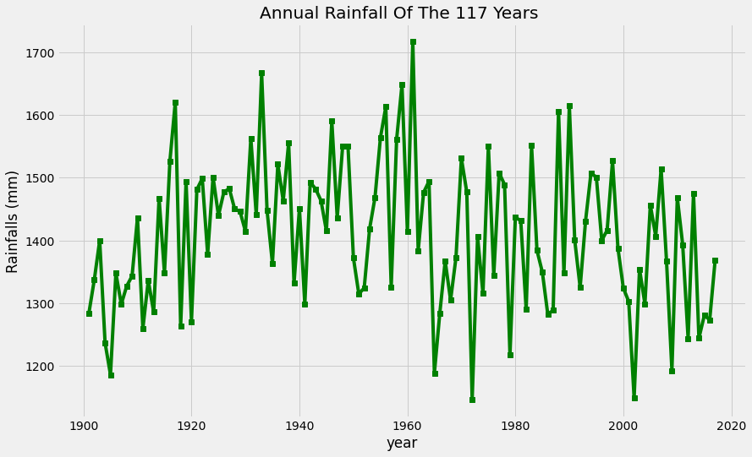

In [11]:

data**.**drop(['annual','subdivision'],axis**=**1)**.**groupby('year')**.**mean()**.**T**.**plot(title**=**'Monthly Rainfall of The 117 Years',figsize**=**(12,7),alpha**=**.15,legend**=False**);

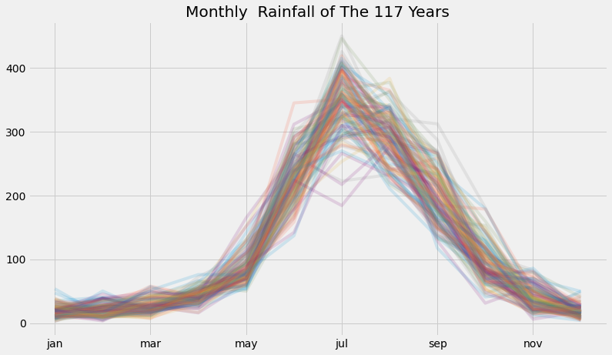

In [12]:

plt**.**style**.**use('seaborn-colorblind')

fig **=** plt**.**figure(figsize**=**(16, 8))

plt**.**xticks(rotation**=**'vertical')

ax**=**sns**.**boxplot(x**=**'subdivision', y**=**'annual', data**=**data);

ax**.**axhline(data['annual']**.**mean(),linestyle**=**'-.',linewidth**=**2,color**=**'g');

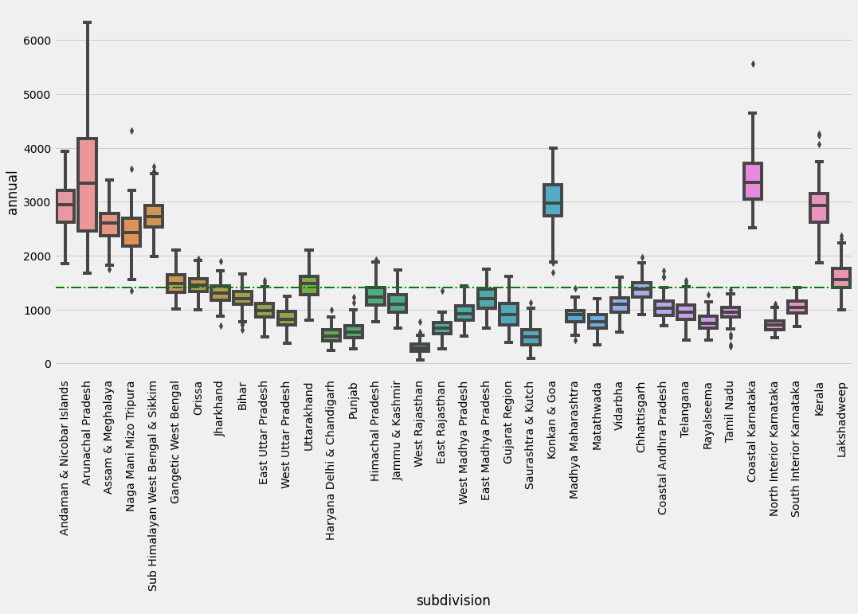

In [13]:

data**.**groupby('subdivision')[['annual']]**.**mean()**.**sort_values('annual')**.**head(3)**.**plot**.**barh(title**=**'Top Most Lowest Rainfalling Subdivision (3)',color**=**'indigo',legend**=False**);

